- NSN COLLEGE OF ENGINEERING AND TECHNOLOGY-GROUP 4
PHASE 1 -SMART WATER MANAGEMENT USING IoT
TEAM MEMBERS
S.NO | NAME | DEPRT | MENTOR NAME
1 | RAMESH D | ECE | KEERTHIKA.S AP/ECE
2 | NAGARAJAN K | ECE | KEERTHIKA.S AP/ECE
3 | JAYAJASEELAN M | ECE | KEERTHIKA.S AP/ECE
4 | NIRMALKUMAR A | ECE | KEERTHIKA.S AP/ECE
5 | MAHENDRAN P | ECE | KEERTHIKA.S AP/ECE

PROBLEM STATEMENT:
Water is a precious resource that can be intelligently managed. Effective water usage demands computerized home water supply management in a culture where water tanks, motors, and pumps are ubiquitous. Water management is crucial for the government and the citizens in countries like Saudi Arabia. The issue is providing a constant, high-quality, low-cost water supply. smart water management system that may be used in structures that do not have access to a constant water supply but instead have water stored in enormous tanks underneath. The GSM module collects water use data from each home in a community and transmits it to the cloud, where it is analyzed. A smart water grid is a hybrid application that uses an inspection mode to identify leaks and measure the resulting height differences to keep track of the tank’s water level. The system automatically deactivates the affected section after detecting any water shortage or malfunction in the system mechanism, such as broken valves, pumps, or pipes. It sends an emergency signal to building managers. It monitors essential water quality elements regularly, and if they fall below acceptable levels, it sends warning signals to the building management, who can take action. Over an extended period, the system monitored and recorded all water quality metrics. The system restarts when the water pump has been reconnected and sends an emergency alert.

FLOW CHART:
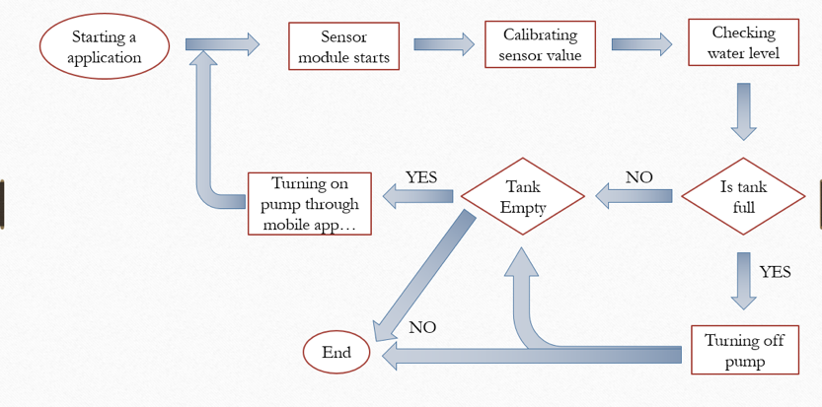
BLOCK DIAGRAM:
